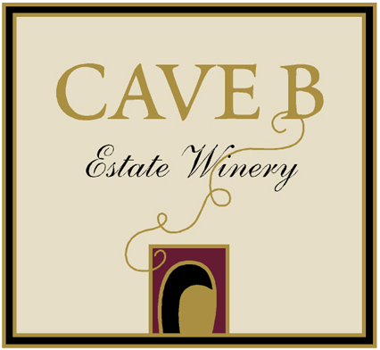

Thank you for your interest in Cave B Estate Winery. We are a 5,000 case/year boutique winery located in the celebrated grape-growing region of the Columbia River Valley. While we are able to gift to a limited number of non-profits, there are many more worthy organizations than we can possibly support through donations. In order to further support the efforts of non-profit organizations, we have created this special pricing program for qualified 501c3s.

Typically, organizations are able to solicit significantly more for our wines than the pricing offered below, making them profitable auction items. We look forward to servicing your requests.

Organization Name:____________________________________________

Address:_____________________________________________________

Event name, date and location: ____________________________________________________________

501c3 number: ____________________________________________________________

Contact name/ phone number: ____________________________________________________________

Contact e-mail: ____________________________________________________________

Wine:
Our non-profit wine selections vary according to inventory. Please indicate the number of cases of each type you are interested in, along with your budget per case, and we will contact you with a current list.

Varietal | Price per case | # of cases | Total Price
White Wine | $134.40 to $159.60 per case |  | $
Red Wine | $147.00 to $235.00 per case |  | $
Premium Wine | $294.00 to $378.00 per case |  | $
*Shipping within WA State | $30.00 per case |  | $
Total |  |  | $
*If you prefer to save shipping costs, wine may be picked up at Cave B Estate Winery no less than one week prior to your event.

Subject to availability. We reserve the right to substitute a similar wine.

Payment:
Make your organization’s check payable to: Cave B.
Please send your completed form & your payment to:
501c3
c/o Montage Management
8015 SE 28th St., Suite 200
Mercer Island, WA 98040

Completed form may alternatively be emailed to: giving@sagecliffe.com.

If you have questions, please contact us at: giving@sagecliffe.com.

